1. 15% (Answer with the program only)

Suppose that $θ=-\frac{π}{2}:\frac{π}{20}:\frac{π}{2}$, and *t* = 0:0.2:4, *a* = 5, and *b* = 2. Use MATLAB code to compute the following expression:

* 1. 
  2. 
  3. 

1. Table 2.1 shows the costs associated with a certain product, and Table 2.2 shows the production volume for the four quarters of the business year. Use MATLAB to find:
2. the quarterly costs for materials, labor, and transportation
3. the total material, labor, and transportation costs for the year
4. and the total quarterly costs.

**(The answer should be multiplied by 103.)**

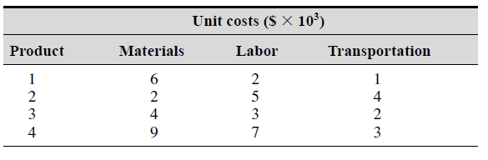

Table2.1 Product cost

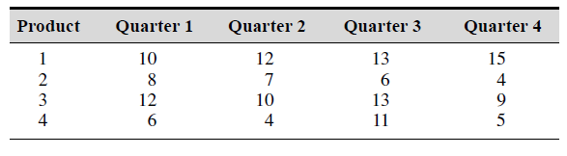

Table2.2 Quarterly production volume

1. 27%

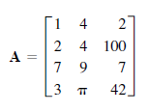

Use MATLAB to find the following:

1. Construct a matrix **B**，it is the transpose of A.
2. Construct a matrix **D,** deleting **3-nd row of A.**
3. Construct vector **x,** its elements is the only third row of **B**.
4. Calculate the sum of all the elements of **x.**
5. Pointwise multiplication of the 2-nd row of A and 3-th column of B.
6. 15% Write a MATLAB SUB-function(name it as **func.m**) to evaluate the members of the sequence, where a, and n are the inputs and the sequence value of is the output of this SUB-function and save it as a script file. Then, write a main function to input the range of the value n from 0 to 20, and =2, and call the SUB-function to evaluate the sequence value, and display the value of n and by using *fprintf*, as the following format:

n 

1. 0
2. 1
3. 4/3

Hint: By using **rats(X, strlen)** to show the fraction number

1. 20% A fenced enclosure consists of a rectangle of length *L* and width 2*R* and a semicircle of radius *R*, as shown in Figure 4. The enclosure is to be built to have an area *A* of 2000 ft2. The cost of the fence is $50 per foot for the curved portion and $40 per foot for the straight sides.
2. Use the fminbnd function to determine with a resolution of 0.01 ft the values of ***R***and ***L***required to minimize the total cost of the fence.
3. compute **the minimum cost**.

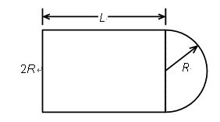

Figure 4